06.09.2016
90 minutes
Name :
TC Number :

EEE 104 DIGITAL DESIGN EXAM
Choose 5 questions
(20) |  | The following Boolean function (with its don't-cares) is given:  F (P,Q,R,S) = Σm (0,2, 3, 4, 6, 7, 8, 10, 11, 14, 15) d (P,Q,R,S) = Σm (1,3, 9, 10, 12, 15)  - Using Karnaugh map method, find and write the most simplified Boolean expression  - Draw the combinational circuit for this function using as few NAND gates as possible.
(20) |  | For the following Karnaugh map, find both minimum sum of products and minimum product of sums expressions.  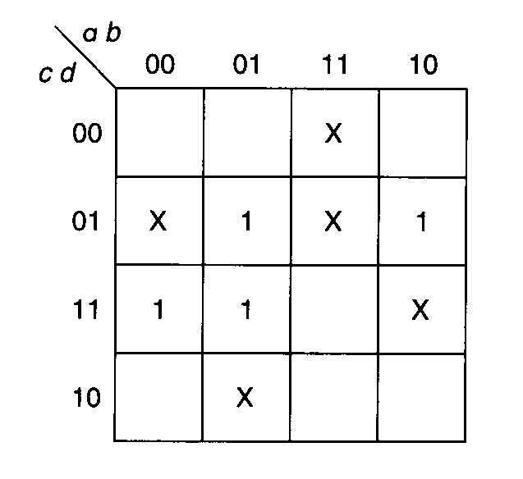
(20) |  | Convert the following Boolean expression into standard SOP and standard POS forms using karnaugh maps:  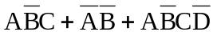
(20) |  | Write the simplest form of the following Boolean expression using karnaugh maps:  X= A’B’C + A’B C’ + A B’C + A B C’
(20) |  | Design a logic circuit which calculates (Q) multiplication of two numbers (A and B) with two bits  (A₁A₀) x (B₁B₀ )= Q₃Q₂Q₁Q₀
(20) |  | For the following Boolean, find both minimum sum of products and minimum product of sums expressions (use Karnaugh map).  X =
(20) |  | Draw the output waveforms ( X , Y and Q ) for the following logic diagram.  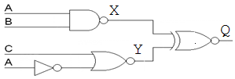  A  B  C  Y  Q  X
(20) |  | Explain combinational and sequential logic circuits. Write the differences between them.
20) |  | Draw the output waveforms ( G₂, G₃, and X ) for the following logic diagram. Find the maximum propagation delay for this circuit. Assume each gate has a propagation delay of 5 ns.  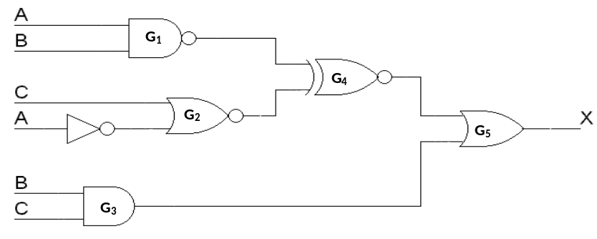  A  B  C  G₂  X  G₁  G₄  G₃

